What is web server?
1. A computer system that hosts website (host multiple web page )
2. Runs web server we used software (Apache, http,IIS)
web server

Shared host
Dedicated host

Web server host web page for multiple user thats call shared host
Web server host web page for single user or firm its called dedicated host

Example – Web Server Software
> Apache ,HTTP server
> Internet Information Services (IIS)
> Lightpd
> Sun Java System Web server
> Jigsaw Server

What is Application Server?
1. A server specifically designed to run applications.
2. Includes both hardware & software that provides an environment for programs to run.
3. Used for:
> Running web applications
> Hosting a hypervisor that manages virtual machines (Vms)
> Distributing and monitoring software update
> Processing data sent from another server
> Provides processing powerand memory to run demanding applications
> Also provides the environment to run specific application

What is forward proxy?
Forward proxy hide the identity of the client

What is reverse proxy?
Reverse proxy hide the server ( Its hide the actual server and redirect to requirement layer )
> When to user reverse proxy
1. When i don’t want to expose the server.
2. To make user feel there is only one server.
3. Provide load balancing for the server.
4. filter out some request.
5. Allows administrators to swap the backend servers without disturbting the traffic

Caching Server?
1. Caching is the process of storing copies of files in a cache, or temporaray storage location , so that they can be accessed more quickly.
2. When ever client access website or application he redirect to cache server.

DNS Server? ( domain name system )
1. Dns server helps to communication between client and server through ip and name.
Example: If we try to open google.com what dns will do. he will check the ip of google.com and help client to communicate with server

Concept:
Topology of DNS server

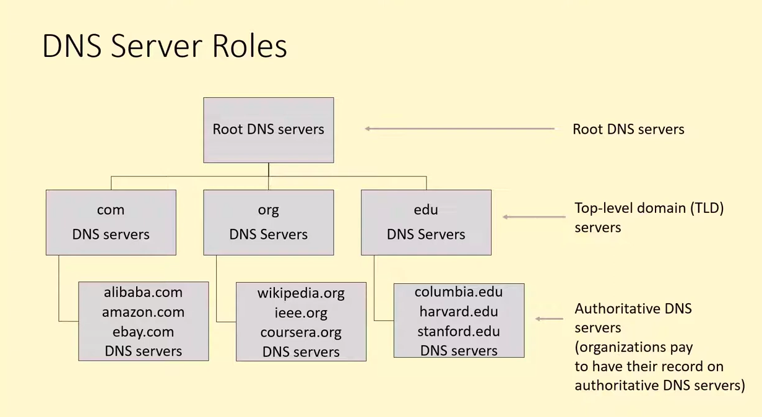
> Root DNS server
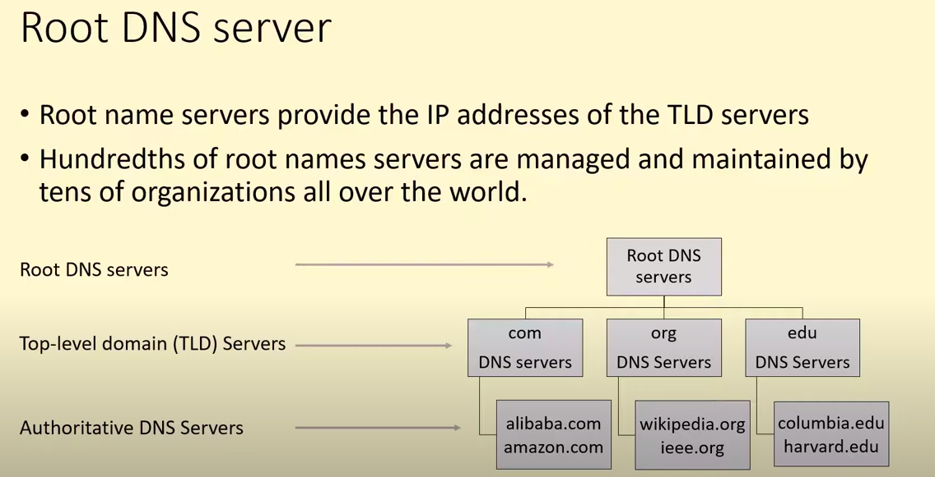

> Top Level Domain server (TLDs)
TLD store the extension of website

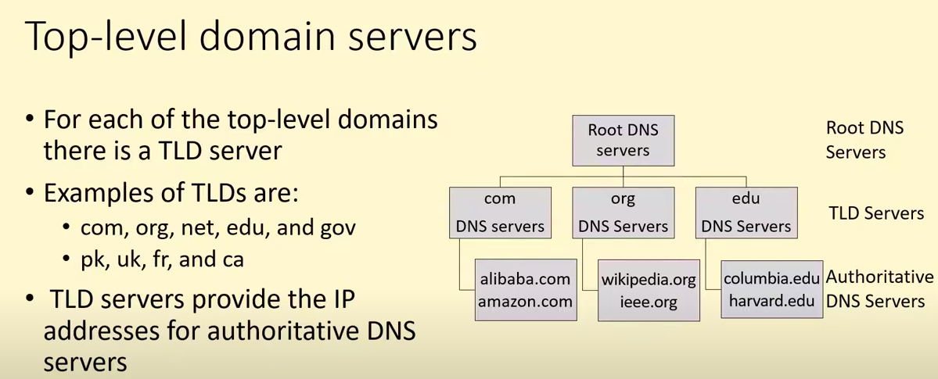

> Authoritative DNS Servers

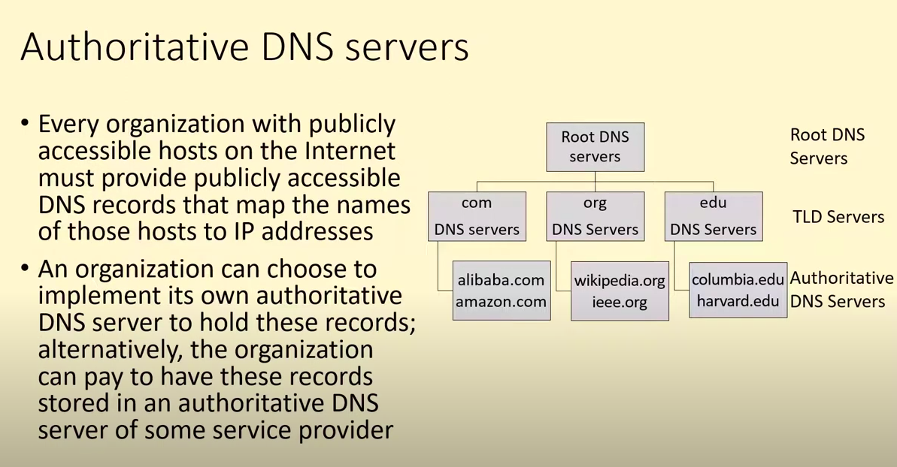
Non – Authoritative DNS Servers

Non-Authoritative Response: If the DNS server doesn't have the requested domain's information, it can forward the query to another DNS server. The response it receives from this other server is considered non-authoritative because it's not coming directly from the source of truth. Instead, it's a response obtained from another server that the initial DNS server trusts to provide accurate information.

DNS Record
DNS (Domain Name System) records are essentially mappings between domain names and IP addresses, allowing computers to translate human-readable domain names (like example.com) into machine-readable IP addresses (like 192.0.2.1). There are various types of DNS records, each serving different purposes:

- A Record (Address Record): Maps a domain name to an IPv4 address. For example, it translates example.com to 192.0.2.1.
- AAAA Record (IPv6 Address Record): Similar to the A record but maps a domain name to an IPv6 address.
- CNAME Record (Canonical Name Record): Creates an alias for a domain name, redirecting it to another domain name. For example, www.example.com might point to example.com.
- MX Record (Mail Exchange Record): Specifies the mail server responsible for receiving email on behalf of a domain.
- TXT Record (Text Record): Used to store any text-based information. Commonly used for verifying domain ownership, setting SPF (Sender Policy Framework) records for email, and other purposes.
- NS Record (Name Server Record): Specifies the authoritative name servers for a domain.
- SOA Record (Start of Authority Record): Provides authoritative information about a DNS zone, including the primary name server, the email address of the domain administrator, etc.
- PTR Record (Pointer Record): Used in reverse DNS lookups to map an IP address to a domain name.
- SRV Record (Service Record): Specifies information about available services within a domain, such as SIP, LDAP, or XMPP.

Create Virtual machine in virtual box
1.Install Nginx by using this command: apt install nginx (root id)
2. Run command (net tools) – its module to check IP
3. ( ifconfiq ) - copied host ip
4. Virtual box Setting we add port rule with below host ip
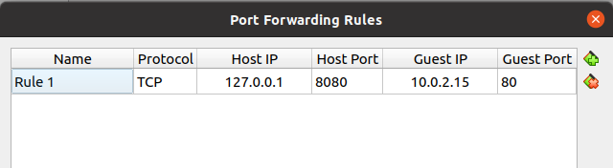
5. access the website with hostip with host port below screenshot
example : 127.0.0.1:80

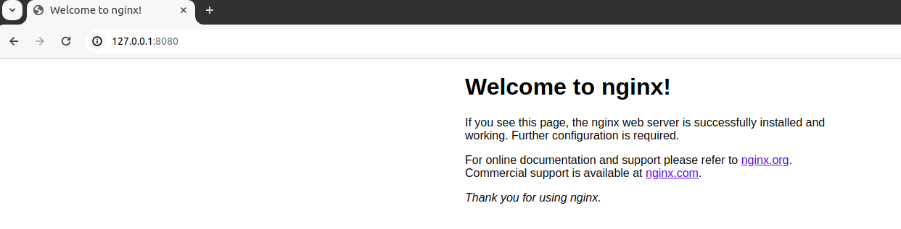

Install UFW in vm and allow port 80 and 22 rest all deny
Run below command
update
apt dist-upgrade
apt install ufw
systemctl status ufw
ufw status
ufw default allow outgoing
ufw default deny incoming
ufw allow 80
ufw allow 22
ufw status numbered

Used telnet, netstat and htop commands to investigate the load on server

telnet google.com 80
netstat – It display network connection
htop- check memory

